**AUTHOR PORTFOLIO FINAL ASSIGNMENT**

Initial AEM Start pages  
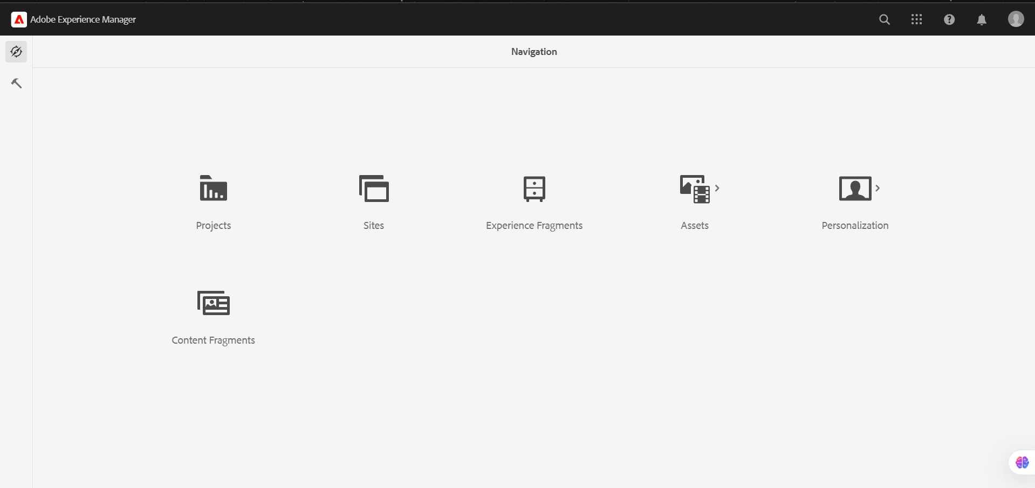

The book page template and the general base template for all the pages.  
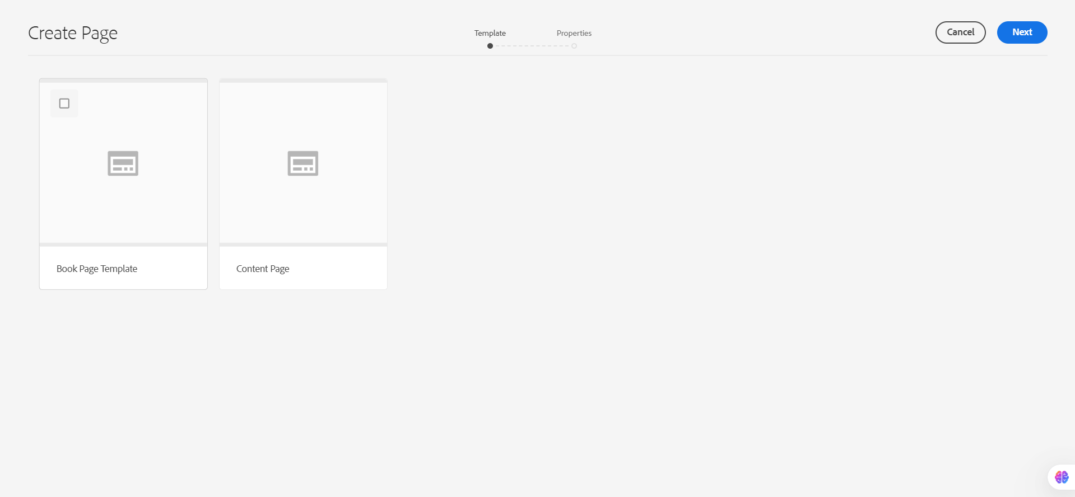



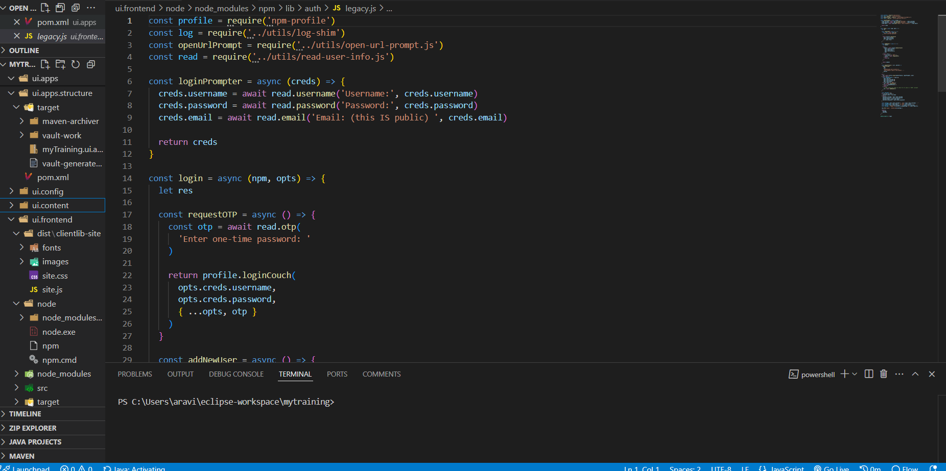

Creation of nodes.

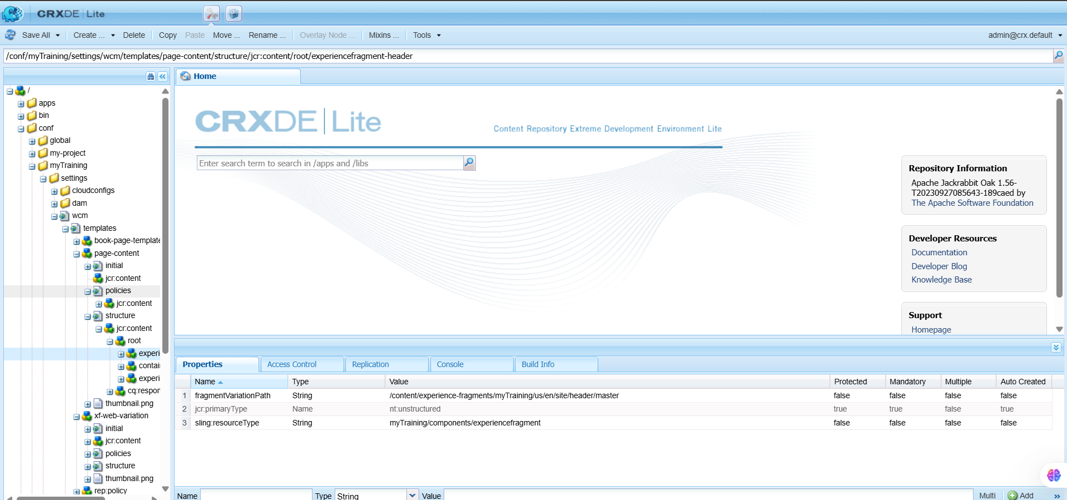  
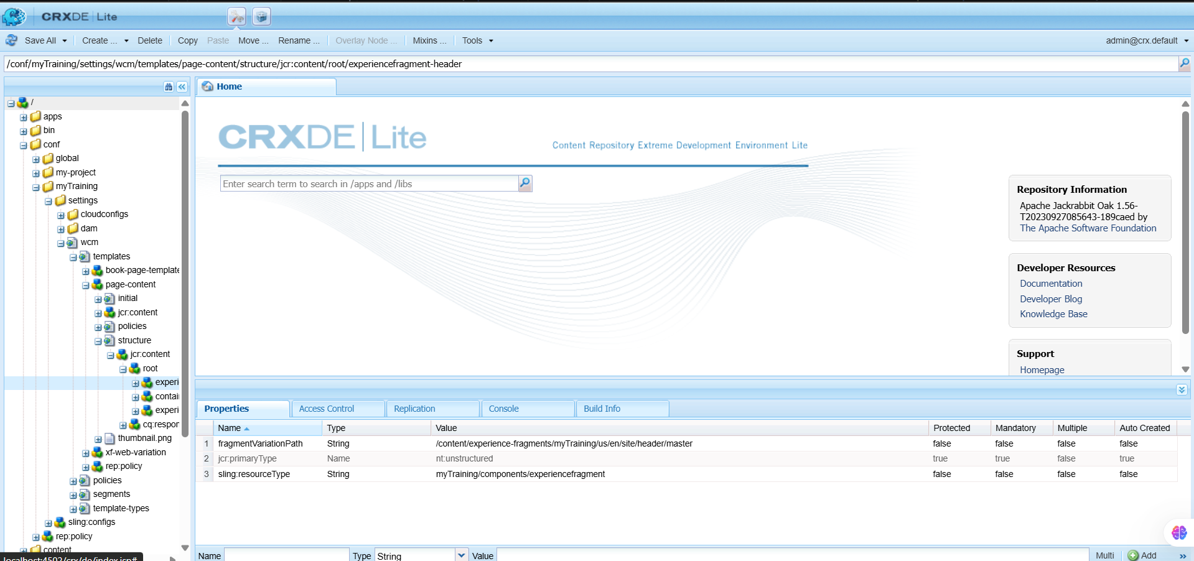

Structure of the author portfolio page.  
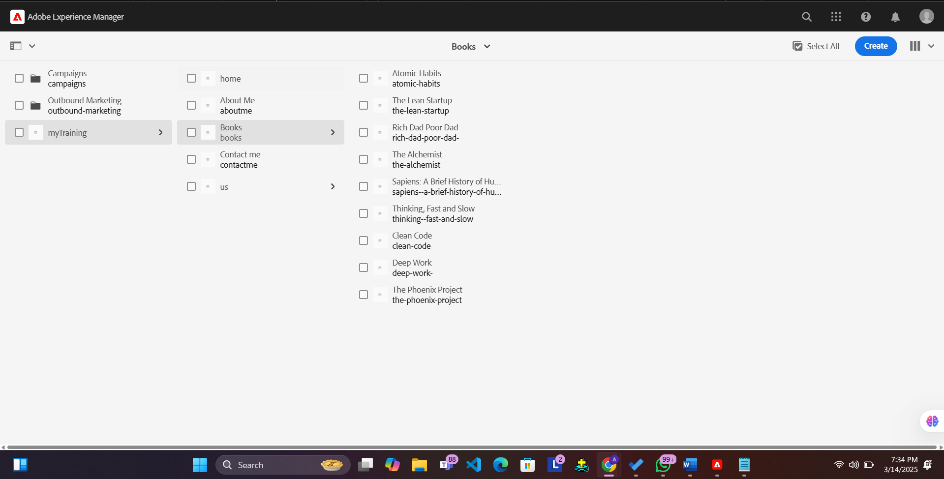

Home Page:

The home page containd the information about all the books present in the page.The header of this page contains

“ home”, “ about me”,” contact me” and “Books”   
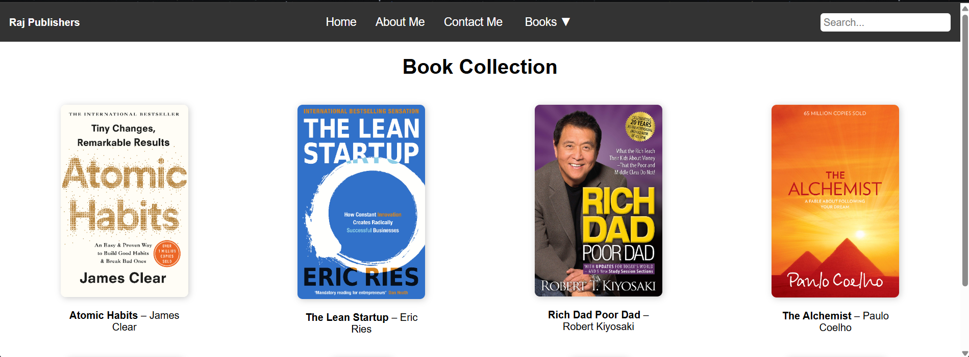

About :

The about page is then designed with the author details and his achievements

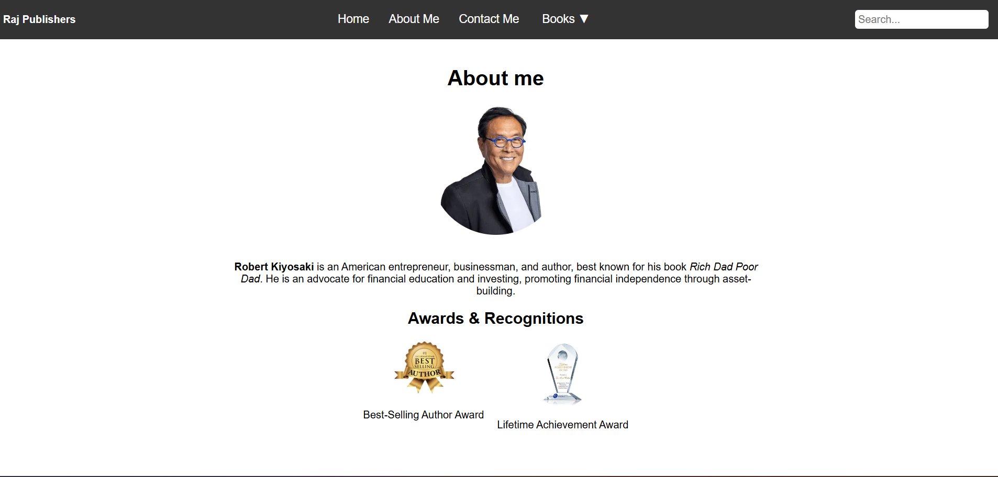

Contact:

The contact page contains all the author information

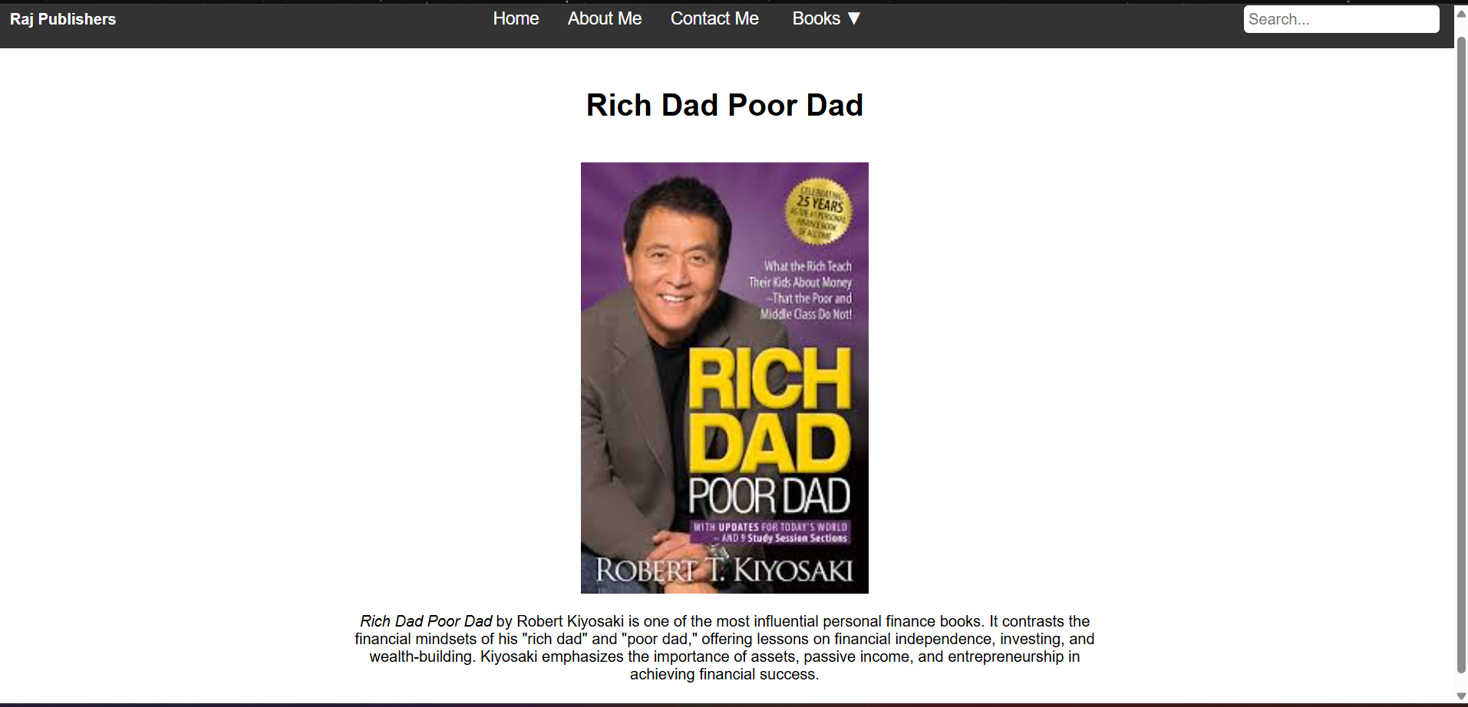

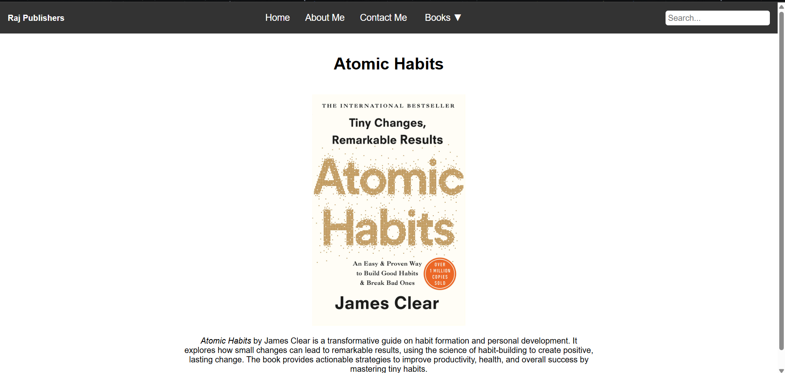

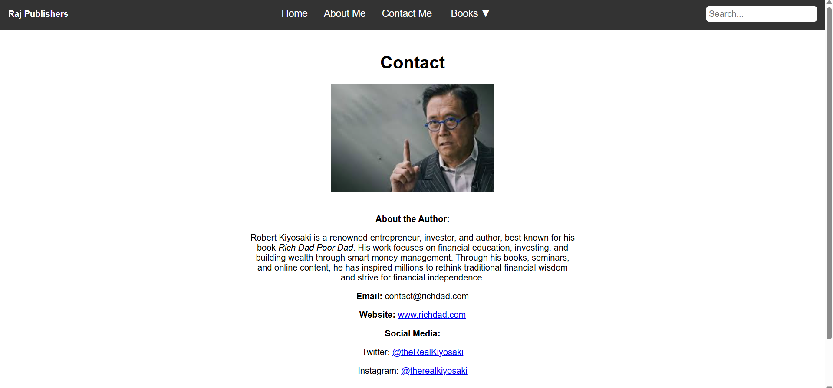



Footer:

The footer section of the page.

